Dan Archer Medical Continuous Education Program

Dates: | Tuesday, 02nd, August, 2016
Time: | 9.30am - 5.30pm (Registration from 9.00am)  Morning tea, light lunch and afternoon tea will be served.
Location: | Carpenter Room, Library and Community Hub Auditorium  2 Conder St, Burwood, NSW 2134.
Registration Cost: | $155 per person for non-distributors of Dan Archer Medical  OR  FREE for our designated distributors* conditions apply  OR  $62 (after 60% Discount) for Practitioner Support Group  Per Person（members, ATMS, AMT, ANTA, AACMA,  MAA, APA, CAA)
-------------------------------------------------------------------------------------------------------------------
8 CPD Points will be awarded (please check with your association as to how many CPD points recognized)
Registrations close 27th, July, 2016
Please make registrations at your earliest convenience as we have limited seats.

www.footbiotec.com

We are proud to have invited Associate Professor, Dr Vivienne Chuter, Head of Discipline and Program Convener for the Discipline of Podiatry in the Faculty of Health and Medicine, The University of Newcastle, to present a lecture on Biomechanics of the foot and lower limb.

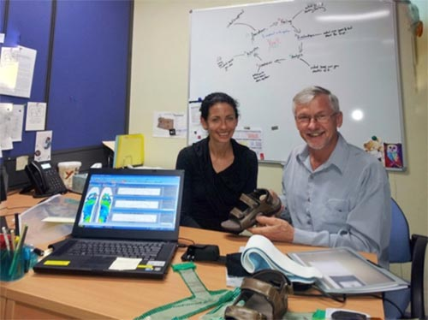
Associate Prof. Vivienne Chuter and Robert Herde of Dan Archer Medical

9:00am - 9:30am Registration
9:30am -10.00am
Open speech
by Dr Daniel Zhang (m.m.b.s chin), Dan Archer Medical

10: 00am – 10: 30am
Brief Education of Communication Skills in Sales
By Robert Herde, the Product Manage Dan Archer Medical

10: 30am – 10: 45am
Morning Tea
10: 45am- 12am

Foundations of Foot and Lower Limb Biomechanics
By Associate Professor Vivienne Chuter
Head of Discipline and Program Convener for the Discipline of Podiatry in the Faculty of Health and Medicine, The University of Newcastle

12pm -1pm
Lunch Break

1pm -2:45pm
The current status of acupuncture for musculoskeletal conditions - evidence and practice
By Chris Zaslawski
Associate Professor, the Deputy Dean, Faculty of Life Health, the Head of Department of TCM
University of Technology, Sydney
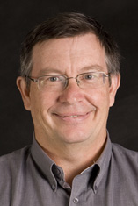

2:45pm- 3pm
Afternoon Tea

3pm-4: 30pm
The Mobilization Techniques for Remedial Massage Therapists in the treatment of Heel pain, Knee Pain and Hip Pain---Theories and Practical Demonstrations
Dr Mehieddin Ghosn (Chiropractor)
Sunshine Natural Health
www.sunshinenaturalhealth.com.au
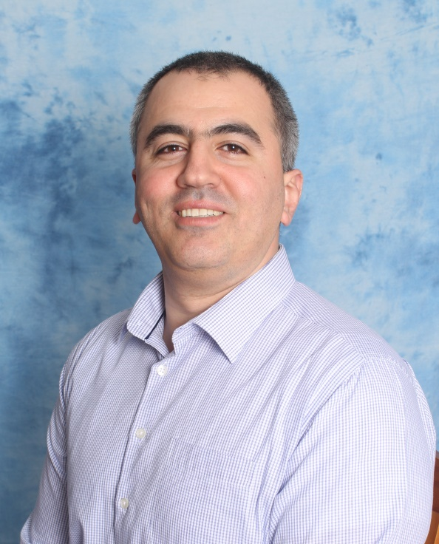
DR Mehieddin Ghosn (Chiropractor)

www.footbiotec.com

REGISTRATION FORM
Full Name:
Practice Name: Distributor: please tick YES ( ) NO ( )
Address:
State: Postcode: Telephone: ( ) Email:

Profession: Physiotherapist Podiatrist Remedial Massage Therapist Chiropractor Acupuncturist
Payment Details (for Non-Distributor Only)
Cheque: Mastercard: Visa: AMOUNT: $
Card Number:
Name on Card:
Authorization Number: Expiry / Signature:

Bank Transfer: Account Name: Dan Archer Medical
Bank: ANZ Account Number: 378955095 BSB: 012129
AMOUNT: $ Reference: Your Name
www.footbiotec.com

To register, please send this completed form to:
Dan Archer Medical Mobile: 0424215789 Wechat: DanArcherMedical
Email: service@footbiotec.com Add: 6/90 Carnarvon St, Silverwater, NSW 2128 Tel: 02-97370985
PROUDLY BROUGHT TO YOU BY Foot Bio-Tec

